Laboratory Manual
(Version 1.0)
for
Personality Devlopment Lab
(BAJMC-157)
BAJMC - I Semester

Compiled by:
Ms. Priyanka Singh & Ms. Supriya Malhotra (Assistant Professor, BVICAM, New Delhi)

Bharati Vidyapeeth’s Institute of Computer Applications
and Management (BVICAM)
A-4, Paschim Vihar, Rohtak Road, New Delhi-63 Visit us at: www.bvicam.in

Index

List of Abbreviations
Declaration
1. | Vision of the Department | 5
2. | Mission of the Department | 5
3. | Programme Educational Objectives (PEOs) | 5
4. | Programme Outcomes (POs) | 6
5. | Institutional Policy for Students’ Conduct | 5
6. | Learning Outcomes of Laboratory Work | 9
7. | Course/Lab Outcomes (COs) | 9
8. | Course/Lab Description | 10
9. | Grading Policy | 11
10. | Lesson Plan | 11
11. | Assignments | 12
Appendix

List of Abbreviations
BTL Bloom’s Taxonomy Level CE Communication Efficacy
CICP Conduct Investigations of Complex Computing Problems CK Computational Knowledge
CO Course Outcome
DAC Departmental Advisory Committee DDS Design and Development of Solutions I&E Innovation and Entrepreneurship I&T Individual & Team Work
IQAC Internal Quality Assurance Cell LLL Life-Long Learning
MTU Modern Tool Usage PA Problem Analysis
PE Professional Ethics
PEO Programme Educational Objective
PL/SQL Programming Language / Structured Query Language PMF Project Management and Finance
PO Programme Outcome

Vision of the Department
To become a Centre of excellence in the field of Journalism and Mass Communication
, to contribute effectively in the rapidly changing global economy directed towards national development ensuring prosperity for the mankind.

Mission of the Department
M1 To produce quality professionals as per global journalism & media industry standards
M2 To foster innovation, entrepreneurial skills, research capabilities and bring all- round development amongst budding professionals.
M3 To promote analytical and collaborative life-long learning skills, among students and faculty members.
M4 To inculcate strong ethical values and professional behavior while giving equal emphasis to social commitment and nation building.

Programme Educational Objectives (PEOs)
The PEO’s for the BAJMC programme are as follows:

The overall objectives of the Learning Outcomes-based Curriculum Framework (LOCF) for Mass communication & Journalism degree are:
PEO1 Exhibit professional, social and entrepreneurial competencies and knowledge for being a successful professional in the Journalism, Media and Entertainment industry.
PEO2 Adopt communication, professional and life skills along with creative and innovative practices to support the communication and entertainment industry as industry ready professionals.

PEO3 Be a lifelong learner and contribute effectively to the Print, Broadcast & Digital Media Industry in an ethical way.
PEO4 Be effective and inspiring journalist for fellow professionals and face the challenges of the rapidly changing multi-dimensional, contemporary world.

Programme Outcomes (POs)
Upon successful completion of the three years BA(JMC) course, students apart from acquiring holistic subject knowledge are expected to acquire dynamic critical thinking and ICT skills. The Programme Outcomes (POs) for the Bachelors of Journalism and Mass Communications (BA(JMC) programme run by Bharati Vidyapeeth’s Institute of Computer Applications and Management (BVICAM) have been identified as follows:

GRADUATE ATTRIBUTES (as per  UGC) | PROGRAMME OUTCOMES
Disciplinary Knowledge: Knowledge of  communication concept and theories. Acquiring knowledge of different dimensions of  communication, perspectives and other related areas of studies. | PO1 (DK). Demonstrate competencies in  fundamentals of communication concepts and theories. Acquire domain knowledge of varied dimensions of communication including historical perspectives and other related areas of study.
Understanding the Role of Press: The  press in democratic society, importance of freedom of press and impact of media in general | PO2 (RP). Identify, and analyze the role of  press in democratic society, importance of freedom of press and impact of media.
Skilled and Industry-ready Professionals:  Strengthening the abilities of a learner by skills, gaining knowledge of the present scenario of M & E industry including  advertising, public relations, corporate | PO3 (SIP). Strengthen abilities of an  individual by gaining knowledge of the present scenario in media and entertainment industry including  advertising, public relations, corporate

communication, digital communication, media management. | communication, digital communication and media management.
Influential and effective communication:  Influential and effective communication ability to share thoughts, ideas and applied skills of communication in its various perspectives like written communication, speech communication etc. | PO4 (IEC). Ability to strike influential and  effective communication in order to share thoughts, ideas and applied skills of communication in its various perspectives like written, verbal etc..
Leadership readiness/ Qualities: To make  learners fluent in multiple facets of leadership .Creating the ability & enhancing the qualities to be an efficient leader. Cultivating key characteristics in learners, to be visionary leaders who can inspire the team to greatness. | PO5 (LQ). Create learners fluent in  multiple facets of leadership in order to be an efficient leader who can be a visionary and inspire their team to greatness.
Critical/ Reflective thinking & language efficiency: Critical/ Reflective thinking ability to employ critical and reflective  thinking along with the ability to create the sense of awareness of one self and society. | PO6 (CT). Ability to employ critical and  reflective thinking along with the ability to create the sense of awareness of one self and society.
Technologically Efficient Professional:  Capability to use various communication technologies and ability to use various software for content creation, content editing for various forms of publishing platforms. | PO7 (TEP). Ability to use various  communication technologies and appropriate software for content creation, content editing for various publishing platforms.
Ethical Awareness: As a communication  learner, one has to understand the importance of ethical values and its application in professional life. | PO8 (EA). Ability to understand the  importance of ethical values and its application in professional life.
Lifelong Learning: Every graduate to be  converted into lifelong learner and | PO9 (LL). Ability to acquire knowledge  and understanding to be a lifelong learner

consistently update himself or herself with current knowledge, skills and technologies. Acquiring Knowledge and creating the understanding in learners that learning will continue throughout life. | by consistently updating oneself with the current trends in knowledge, skills and technologies.
Research-related Skills: A sense of inquiry  and investigation for raising relevant and contemporary questions, synthesizing and articulating. | PO10 (RRS). Ability to recognize, inquire  and investigate for raising relevant and contemporary questions, synthesizing and articulating the same.
Cooperation/ Team work: Building a  team, motivating and inspiring the team members to work up with cooperation to their utmost efficiency. | PO11 (C&T). Ability to work in multi-  disciplinary team collaboration both as a member and leader as per need.

Institutional Policy for Students’ Conduct
The following guidelines shall be followed:-

  - All the students in their introductory Lab. shall be assigned a system, which shall be their workplace for the complete semester. Students can store records of all their Lab. assignments on their individual workstations.
  - Introductory Lab. shall include an introduction to the appropriate software/tool, followed by a basic Introductory Assignment having Practice Questions. All the students are expected to complete this assignment within a week time, as the same shall be assessed through a lab. test.
  - Each week the instructor, in parallel to respective topics covered in the theory lecture, shall assign a set of practical problems to the students in form of Assignments (A, B, C, ). The problems in these assignments shall be divided
into two parts. The first set of Problems shall be compulsory for all the students and its record need to be maintained in the Prcatical File, having prescribed

format, as given in Appendix-A. All the students should get the weekly assigntment checked and signed in the Practical File by the respective teacher in the immediate succeeding week. The second set of problems are Advanced Problems and shall be optional. Student may solve these advanced problems for their further practice.
  - Cellular phones, pagers, CD players, radios and similar devices are prohibited in the classrooms, laboratories and examination halls.
  - Laptop-size computers / Tablets may be used in lectures for the purpose of taking notes or working on team-projects.
  - The internal practical exam shall be conducted towards the end of the semester and shall include the complete set of Lab exercises conducted as syllabus. However, students shall be assessed on continuos basis through overall performances in regular lab. tests, both announced and surprise and viva-voce.
  - The respective faculty shall prepare and submit sufficient number of practical sets of computing problems to the Dean (Examinations), atleast two weeks prior to the actual exam. It is the responsibility of the faculty to ensure that a set should not be repeated for more than 5 students in a given batch.
  - The exam shall be of 3 hours duration where the student shall be expected to implement solutions to his/her assigned set of problems on appropriate software tools in the lab.
  - Once implemented, student shall also appropriately document code implemented in the assigned answer sheets, which shall be submitted at the end of the examination. All the students shall also appear for viva-voce examination during the exam.
  - Co-operate, Collaborate and Explore for the best individual learning outcomes but copying or entering into the act of plagiarism is strictly prohibited.

Learning Outcomes of Laboratory Work

The student shall demonstrate the ability to:

- Verify and Implement the concepts and theory learnt in class.

- Code and use Software Tools to solve problems and present their optimal solutions.
- Apply numerical/statistical formulas for solving problems/questions.

- Develop and apply critical thinking skills.

- Design and present Lab as well as project reports.

- Apply appropriate methods for the analysis of raw data.

- Perform logical troubleshooting as and when required.

- Work effectively as a member of a team in varying roles as need be.

- Communicate effectively, both oral and written.

- Cultivate ethics, social empathy, creativity and entrepreneurial mindset.

Course/Lab Outcomes (COs)
CO1 Make use of presentation skills for professional development. (BTL-3)

CO2 Enhance team management skills.(BTL-6)

CO3 Compose letter, e-mail, resume and portfolio. (BTL-6)

CO4 Conduct SWOT and TAT analysis. . (BTL-3)

Index

List of Abbreviations
Declaration
1. | Vision of the Department | 5
2. | Mission of the Department | 5
3. | Programme Educational Objectives (PEOs) | 5
4. | Programme Outcomes (POs) | 6
5. | Institutional Policy for Students’ Conduct | 5
6. | Learning Outcomes of Laboratory Work | 9
7. | Course/Lab Outcomes (COs) | 9
8. | Course/Lab Description | 10
9. | Grading Policy | 11
10. | Lesson Plan | 11
11. | Assignments | 12
Appendix

Bharati Vidyapeeth's Institute of
Computer Applications and Management (BVICAM)

INDEX

S.NO | TOPICS | PAGE. NO
1. | Personality Development Lab Syllabus as per GGSIP University
2. | Lab Module – 1  Role Play
3. | Lab Module – 2  Presentation and group discussion Etiquettes
4. | Lab Module – 3  Thematic Appreciation Test (TAT)
5. | Lab Module – 4  Team building exercises and crisis management
6. | Lab Module – 5  Situation based behavior & its analysis
7. | Lab Module – 6  Writing letters and emails – officials and non-officials
8. | Lab Module – 7  Mock interviews
9. | Lab Module – 8  Professional Resume Writing
10. | Lab Module – 9  Portfolio Development
11. | Conclusion
12. | References

BACHELOR OF ARTS
(JOURNALISM AND MASS COMMUNICATION)

FIRST SEMESTER
PERSONALTY LAB

COURSE CODE: BA (JMC) 353 | L: 0 T/P: 2 | CREDITS: 2
External Evaluation: 60 Marks | Internal Evaluation: 40 Marks | Total Marks: 100

OBJECTIVES OF THE COURSE
On completion of this course, the student should be able to:
1. Define basics of Personality Development
2. Understand listening, speaking writing etiquette
3. Utilize knowledge gained in developing a positive personal attitude.

EXERCISES/ASSIGNMENTS

- Exercise: In different situation to organize an event, identify various roles of candidates as per their skills and knowledge.

- Do content writing on related topics, which highlights your personality or your career for group discussion.

- Lab Exercise/Assignment: Practicing, analysis of situation

- Exercise/Assignment: Crisis management, how a student will manage in case of client servicing team and in case of operation team.

- Exercise/Assignment: Identify various situations-based behaviors & its analysis.

- Exercise/Assignment: Write a formal letter.

- Exercise/Assignment: Write a formal email-writing.

- Exercise/Assignment: Prepare mock-interview question for two celebrities.

- Exercise/Assignment: Student are assigning to create their resume.

- Make your portfolio by adding all your achievements, awards, audio, video and good work into it.

Internal Assessment: The student should maintain a file and soft copy of her/his assignments/jobs duly checked and signed by the concerned faculty. The marks assigned for internal evaluation are 40.

LAB MODULE – 1

ROLE PLAYS

SUMMARY OF KEY CONCEPTS

- Role-playing takes place between two or more people, who act out roles to explore a particular scenario.

- It's most useful to help you or your team prepare for unfamiliar or difficult situations. For example, you can use it to practice sales meetings, interviews, presentations, or emotionally difficult conversations, such as when you’re resolving conflict.

- By acting scenarios like these out, you can explore how other people are likely to respond to different approaches; and you can get a feel for approaches that are likely to work, and for those that might be counter-productive. You can also get a sense of what other people are likely to be thinking and feeling in the situation.

- Also, by preparing for a situation using role-play, you build up experience and self-confidence with handling the situation in real life, and you can develop quick and instinctively correct reactions to situations. This means that you'll react effectively as situations evolve, rather than making mistakes or becoming overwhelmed by events.

METHODS AND APPROACH

How to Use Role Play
It is easy to set up and run a role-playing session. It will help to follow the five steps below.

Step 1: Identify the Situation
- To start the process, gather people together, introduce the problem, and encourage an open discussion to uncover all of the relevant issues. This will help people to start thinking about the problem before the role-play begins.

- If you're in a group and people are unfamiliar with each other, consider doing some icebreaker exercises beforehand.

Step 2: Add Details
- Next, set up a scenario in enough detail for it to feel "real." Make sure that everyone is clear about the problem that you're trying to work through, and that they know what you want to achieve by the end of the session.

Step 3: Assign Roles
- Once you've set the scene, identify the various fictional characters involved in the scenario. Some of these may be people who have to deal with the situation when it actually happens (for example, salespeople). Others will represent people who are supportive or hostile, depending on the scenario (for example, an angry client).

Step 4: Act Out the Scenario
- Each person can then assume their role, and act out the situation, trying different approaches where necessary.

- It can be useful if the scenarios build up in intensity. For instance, if the aim of your role-play is to practice a sales meeting, the person playing the role of the potential client could start as an ideal client, and, through a series of scenarios, could become increasingly hostile and difficult. You could then test and practice different approaches for handling situations, so that you can give participants experience in handling them.

Step 5: Discuss What You Have Learned
- When you finish the role-play, discuss what you've learned, so that you or the people involved can learn from the experience.

LAB EXERCISE / ASSIGNMENT:
In different situation to organize an event, identify various roles of candidates as per their skills and knowledge.

Lab Module – 2

PRESENTATION AND GROUP DISCUSSION ETIQUETTES

SUMMARY OF KEY CONCEPTS
Etiquette and manners carry a huge weightage in any Group Discussion. What we speak comes a lot later. What first holds the attention of the judges is the way one carries themselves. It is very true that the first impression is the best impression. It is the first impression that lasts longer. For a candidate appearing in the group discussion has a restricted time to present themselves.

The way the candidate gets dressed in formal attire, the way they walk, their body language, everything speaks about the personality of the candidate. To be present on time is very important. That doesn’t mean reaching much ahead of time, but precisely be on specified time in the formals. Again, the way we walk into our allocated seats also express our personality. Be confident but not arrogant.

METHOS AND APPROACH
It is necessary to get noticed by the evaluators and for that you need to learn the ways to remain active throughout the session.

- Analyzing the discussion and coming up with ideas or subtopics that are not mentioned by the other candidates is one way to stay connected in the discussion.
- Even if your knowledge related to the topic is not vast enough, you can talk on the same topic considering from a different point of view.
- There will be cases where the discussion may go haywire, take the lead and try to bring the discussion back into the route.
- The last thing to add is appreciating the point of view of the other candidates in an appealing way.

What is a Group Discussion?

A Group Discussion (GD) is a technique used by corporate companies, educational institutes, and other organizations to judge the communication skills of the participant. Communication skills are a crucial factor when compared to technical knowledge in any corporate environment.

What Skills are Judged in GD?
- How good are you while communicating with others?

- How do you behave and interact with a group?

- How open-minded are you?

- Your listening skills.

- How do you put forward your views?

- Your leadership and decision-making skills.

- Your analytical skills and subject knowledge.

- Your problem solving and critical thinking skills.

- Your attitude and confidence.

Team building exercise and crisis management
Teams are more efficient and collaborative when they use Huddle. However, even strong teams can benefit from team building exercises; they're a great way to improve communication, morale, motivation and productivity. This helps employees or new teams to get to know each other better and learn about their strengths and weaknesses. Team building games and activities can be used by any business, large or small, to promote better teamwork in the workplace. As most business owners and managers know, great teamwork is one of the key factors associated with a company’s success.

There are four main types of teams building activities, which include:

- Communication activities

- Problem solving and decision-making activities

- Adaptability and planning activities

- Trust-building activities

SAMPLE: Current issues related topic based on the field of:
- Political & related issues
- Crime & related issues
- Health & related issues
- Education & related issues
- Lifestyle & related issues

Lab Exercise/Assignment: Selection of topic
Do content writing on related topics, which highlights your personality or your career for group discussion.
Lab Module – 3

THEMATIC APPRECIATION TESTS (TAT)

SUMMARY OF KEY CONCEPTS

The TAT is a broadly used projective test for the valuation of children and adults. It is designed to reveal an individual’s perception of interpersonal relationships. This also include making a point of view on any particular topic and construct it more presentable.

METHOS AND APPROACH

- It is a test of you have to imagine and write a story. Remember it is a story writing and not describing the pictures.
- Your story should clearly have a hero. Now this Hero is very important. This is so because this Hero represents you.
- The thing a person writes or says or in other words the kind of reaction a person gives depicts his/her personality in a great deal. Hence the kind of story you make depict your personality to a certain extent.
- Thus, the Hero represents you. So, make the Hero a positive charter.

Concept of TAT

Thirty-one picture cards serve as stimuli for stories and descriptions about relationships or social situations.

Cards include specific subsets for boys, girls, men, and women.

The test is useful as part of a comprehensive study of personality and in the interpretation of behavior disorders, psychosomatic illnesses, neuroses, and psychoses.
The TAT involves showing people a series of picture cards depicting a variety of ambiguous characters (that may include men, women, and/or children), scenes, and situations.
They are then asked to tell as dramatic a story as they can for each picture presented, including:

- What has led up to the event shown.

- What is happening in the scene?

- The thoughts and feelings of characters.

- The outcome of the story.

Why the TAT Is Used

The TAT can be utilized by therapists in a number of different ways. Some of these include:
- To learn more about a person. In this way, the test acts as something of an icebreaker while providing useful information about potential emotional conflicts the client may have.

- To help people express their feelings. The TAT is often used as a therapeutic tool to allow clients to express feelings in a non-direct way. A client may not yet be able to express a certain feeling directly, but they might be able to identify the emotion when viewed from an outside perspective.

- To explore themes related to the person's life experiences. Clients dealing with problems such as job loss, divorce, or health issues might interpret the ambiguous scenes and relating to their unique circumstances, allowing deeper exploration over the course of therapy.

- To assess someone for psychological conditions. The test is sometimes used as a tool to assess personality or thought disorders.

- To evaluate crime suspects. Clinicians may administer the test to criminals to assess the risk of recidivism or to determine if a person matches the profile of a crime suspect.

- To screen job candidates. This is sometimes used to determine if people are suited to particular roles, especially positions that require coping with stress and evaluating vague situations such as military leadership and law enforcement positions.

SAMPLE:

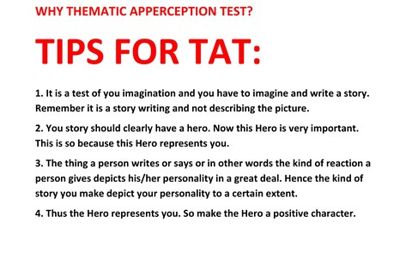

Picture source: google
Lab Exercise/Assignment 3: Practicing, analysis of situation.

Lab Module – 4

TEAM BUILDING EXERCISES AND CRISIS MANAGEMENT

SUMMARY OF KEY CONCEPTS
They are also helpful for getting people to come to the party dressed as themselves and demonstrate the value of Myers and Briggs' personality typing to people who may be skeptical about it.
The following icebreakers are designed to reveal something about personality type in real and accessible ways. You can refer back to the activities later in the workshop so participants can examine their behaviour in retrospect and see how it all fits together.
METHOS AND APPROACH
And here are some tips for more conventional team building activities:
- Practise the team building exercise yourself first to check that it works, check timings, materials, and to ensure you have all the answers. Anticipation and planning are vital.
- Make sure all team building games instructions are clear and complete - essential for keeping control and credibility.
- Become proficient yourself first with any team building games or equipment that you use.
- Always have spare materials and equipment to allow for more people, breakages and the inevitable requests for freebie items ("Can I take a couple home for my kids?")
- Take extra care when organising teambuilding activities and games for young people, especially kids’ activities and children's party games.
- Attaching a theme to team-building activities helps make the exercises more memorable - see the free motivational posters for ideas and examples.

1. Picture This!
Pair up the participants. Ask one person to draw a basic picture, keeping the image secret from her partner. Then, have the artist describe the basic shapes of the picture and the other person has to draw it and see how close they get to the original picture. Have participants move around the room and repeat the exercise with as many drawing partners as time allows. Ask the artists to observe how they describe the picture. What words do they use (big picture overview or other details)? Is communication easier with some people than with others? Did they have to change the way they described the picture to get the message across?

2. The Artist Game
Here’s another art-inspired exercise that draws out a person’s thinking and communication style. Give everyone a piece of paper and a pencil. In five minutes, they must draw a picture that represents who they are without using any words or numbers. The host collects the drawings and shows them in the workshop and participants must guess who drew each picture. After this, have the artist introduce himself and explain how the work symbolizes him. What words does he choose? How does he communicate with the group?

3. Story Time Game
The host starts a story by saying a sentence. It then goes in a circle, with each participant repeating the sentence that has just been said and then adding a new sentence onto the story. This exercise is good at exposing the differences in the Sensing and Intuitive thinking style. Sensors typically will continue the story in a linear fashion whereas Intuitive will play around with ideas, adding their own interpretations as to how each of the characters might think, act and feel. How do Sensors react if the story wanders off paste?

4. Kangaroo Court Game
Choose this ice-breaker if the purpose of the workshop is to improve team effectiveness. Participants should know each other and ideally, there should have been an incident that irritated members of the group. Referring to the incident, announce that you are holding a kangaroo court to try the guilty parties. Name the defendants. Select a judge, a prosecuting attorney and a lawyer for the defence. Swear in the jury. Write up formal charges and hold your trial in whatever way your participants choose.
As you observe, make a note of each participant’s approach to law and order. Do they see the ‘crime’ in black-and-white terms or is their approach more nuanced? Do they prefer punishment over forgiveness? What type of argument sways their opinion?

5. “I Agree” Poster
Make a poster containing several statements, assumptions or cliches about a topic relevant to your business. For example, you might riff on the topic of “successful leaders” who…
- Are tough and commanding
- Must know it all
- Nurture and develop others
- Are specialists in their field
- Are born, not made
- Are empathetic
- Must have a strong vision
- Are creative and innovative
- Require a formal title and position in the company
- Are ethical and values-driven.
Ask participants to vote on the statements they agree with. You can use the results to lead a discussion on the personality components of leadership, or refer to the results later in the workshop when discussing what each personality type requires from an effective manager.

6. The Dominant Hand
Give each participant a pen and paper and ask them to sign their name. Now, ask them to repeat the exercise using their non-dominant hand. Ask the participants, which hand felt more normal and natural? Is it possible to sign your name effectively using your non-dominant hand? What would happen if you were forced to write with this hand all the time? This simple exercise shows the power of preference and is a nice way of introducing personality theory.

7. The M&M House
This perennial workshop favourite is useful for illustrating the differences between the Perceiving and Judging types; it also works well as an icebreaker. Assuming you’ve assessed everyone’s type before the workshop (this is recommended), separate participants into three groups: one comprised of Judgers, one comprised of Perceivers, and a mixed group. Give each group 10-15 minutes to construct a two-dimensional house out of M&Ms.
When the time is up, have everyone discuss how the activity went. Did the group finish? If so, it’s likely a “J” group. Is the home colour-coordinated? Also, likely a “J” group. Are any of the homes particularly unusual? This group was probably comprised of “Ps.” This activity shows how differently we approach tasks. Did the mixed group leverage their differences to create a better result?

8. Planning a Party
Match up two participants, an Introvert and an Extravert, and ask them to plan a party for themselves (you can use small E and I groups for larger numbers of participants). The participants typically will approach this task in opposing ways. The Introvert will want a small, intimate and close-knit party. The Extravert will expect lots of action, excitement and entertainment. Introversion/extraversion is generally considered to be the easiest dichotomy to understand, so this is a great ice-breaker exercise for really drilling home the differences in type.

What these icebreakers have in common
Ice breaker exercises are a great way to showcase the differences between the 16 personality types. As participants engage in the exercises, walk around the room, make notes, and perhaps take some photographs. Notice that:
- Extraverts will talk about the exercise aloud while taking part, often dominating the conversation.
- Introverts may take a step back for some think time (or to cringe at the prospect of participating in an icebreaker exercise!)
- EF types will use the ice breaker as an excuse to get to know every person in the room.
- NTs might well become competitive.
- Judgers will want to complete the activity, even when you ask them to stop.
- ENP types might ignore the rules; or they will not listen properly when you give the instructions!

EXERCISE: Crisis management, how a student will manage in case of client servicing team and in case of operation team.

\

Lab Module – 5

Situation based behaviors & its analysis

SUMMARY OF KEY CONCEPT

Every person has different characteristic and different behaviors and on the basis of their characteristics, qualities and principles. Behavior analysis is rooted in the behaviorist tradition and utilizes learning principles to bring about behavior change. Some branches of psychology strive to understand underlying cognitions, but behavioral psychology is not concerned with mentalistic causes of behavior and instead focuses on the behavior itself.

Behavior analysis has robust practical applications in mental health treatment and organizational psychology, particularly when focused on helping children and adults learn new behaviors or reduce problem behaviors. Behavior analysis is often used to build abilities in children and adults with disabilities increase academic skills in school settings, and enhance employee performance on different levels.

METHOS AND APPROACH

Step 1: Analyze the Situation
A situation analysis is the first step in the social and behavior change communication change (SBCC) process including one that focuses on CHWs. The situation analysis answers questions about existing opportunities, resources, challenges and barriers related to improved CHW behavior.

You can conduct this step using one of the following two options:
The following summarizes the key activities for the situation analysis:

Conduct a Review of Program Data
This includes service records, quarterly reports, policy documents and informal interview. Then develop a focused problem statement. This statement will help to ensure the intervention focuses on one specific behavioral issue at once. Example: “Community Health Workers are not consistently referring women of reproductive age for family planning services.”

Draft a Shared Vision
A shared vision provides a picture of what the situation will look like when the SBCC effort is completely successful. Example: “In 2020, CHWs spend time discussing methods with newly married couples and encourage them to ask questions and refer those with demonstrated need for FP services.” Guidelines on what to consider when drafting this vision.

Gather Information and Summarize Findings
If you chose to conduct the CHW Performance Assessment, follow the steps to gather the information and summarize your findings through the link. If you chose to rely on secondary data, follow the steps in this how-to guide for conducting a Situation Analysis using secondary data to answer the key questions about CHWs and their work environment.

Examples of secondary data you might consider to gather this information include:

- CHW monitoring or support supervision reports
- Service delivery statistics
- Program reports
- Key informant interviews
- Government, partner and donor activity evaluation reports
- Government policy documents regulating CHWs and primary health services
- Whether you use the CHW Performance Assessment or a Secondary Data Analysis, the findings of your situation analysis should be framed around the four categories of CHW performance:

Expectation: Do CHWs understand the performance expected and the definition of quality?
Opportunity: Do CHWs have the environment and necessary resources available to support performance?
Ability: Do CHWs have the skills and knowledge necessary to do the tasks in his/her scope of work and feel competent in doing so?
Motivation: Is there sufficient reward and lack of negative consequences to make CHWs want to do his/her job?
Use this Needs Summary Table from the CHW Performance Assessment to summarize the findings. Then prioritize those needs using the Prioritization Matrix and Action Tracker.

If you prioritized Expectation, Opportunity or Ability barriers, proceed to Other Resources for tools, resources and programmatic examples to improve Expectation, Opportunity and Ability performance gaps. If you prioritized Motivation barriers, identify which motivational barriers are relevant to your CHWs and then proceed through the I-Kit to design your intervention.

Lab Module – 6

WRITING LETTERS AND EMAIL- OFFICIAL AND NON-OFFICIAL

SUMMARY OF KEY CONCEPTS

Letter writing is an essential skill. Despite the prevalence of emails and text messages, everyone has to write letters at some point. Letters of complaint, job applications, thank you letters, letters requesting changes or making suggestions the list goes on and on. Encouraging adults to write letters from an early age will improve their communication, social and handwriting skills, and teach them what they need to know about writing and structuring letters.

Formal letters
These are sometimes known as business letters. They are written in a strictly formal style. Such letters are always written on an A4 (8" x 11") sheet of paper. They can be folded three times so that the address to which the letter is being sent can appear in the window of a business envelope. The layout is always the same.

Structure:

- The sender’s address is put at the top right-hand side
- Include telephone number and email if available
- The address of the person receiving the letter goes on the left-hand side below the sender's address
- The date
- Greeting, Dear Sir or Madam. You can use the titles Miss, Mrs. or Mr. if you know the name of the person to whom you are writing
- The message
- Complimentary close, Yours faithfully or Yours sincerely
- Signature
- Write name in block letters (this is to ensure that the person receiving the letter knows exactly who has sent it. Signatures may not be very clear)

Informal letters
These are letters to friends and relations, or people you know well.
Structure:

- The sender's address should always appear on the top right-hand corner of the page.
- Include telephone number and email if available
- Greeting: There are several variations that can be used depending on how well you know the person: Dear Mary, Hi ABC, Greetings
- Complimentary close: short comment, for example Love, Lots of love, With thanks, See you soon

Tips for writing good letters

- Make sure that they are well written. It can be very annoying for someone to have to struggle to read handwriting. Always use your best and clearest handwriting.
- Make sure all your contact details are clearly written down at the top of the letter. If they are not, then you might not get a reply. The correct address is essential.
- Think about what you want to say. If necessary, make some notes on a separate sheet of paper first. This will ensure that you do not forget anything.

- Think about to whom you are writing the letter. Use the right style of writing and language formal or informal, business like or friendly.
- Lay out your letter using paragraphs. This makes it easier for the reader.

SAMPLE: Lab 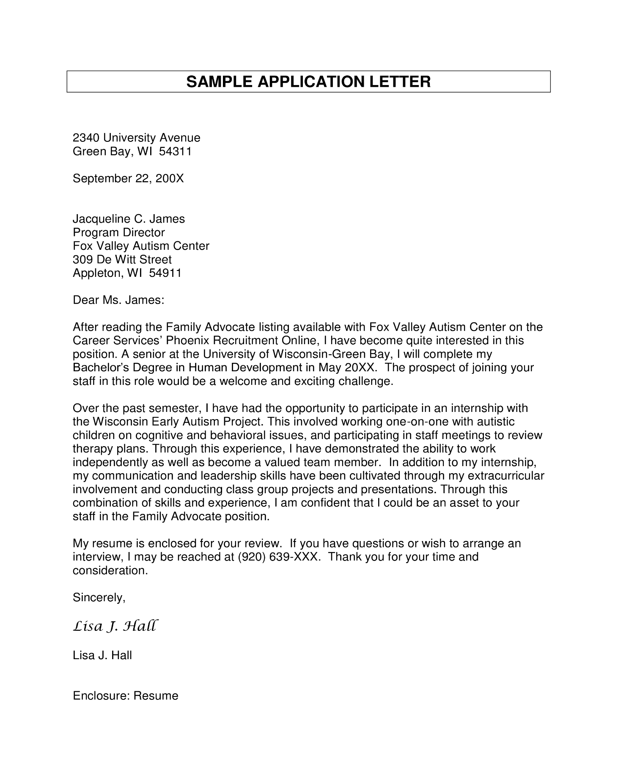
Exercise/Assignment: Write a formal letter

Formal emails are often called for when you’re sending an email to someone you don’t know well. A formal email is also the right choice for some business situations. If you’re not sure whether to send a formal or informal email, it’s usually better to send a formal message.
If your workplace has a formal environment, use formal emails with your boss and colleagues unless you’re told to do otherwise. Many workplaces are moving towards a more casual environment and this often carries over to email communications. If you’re not sure what’s right for your workplace, ask.
If you’re not sure how to start an email, these five steps can help you craft a professional message:

1. Identify your goal
Before you write an email, ask yourself what you want the recipient to do after they’ve read it. Once you’ve determined the purpose of your email, you can ensure everything you include in your message supports this action.

2. Consider your audience
When you compose an email message, make sure your tone matches your audience.

3. Keep it concise
Your audience might have little time to read through your email, so make it as brief as possible without leaving out key information. Try not to address too many subjects at once as this can make your message lengthy, challenging to read and difficult to take action on. When editing your email, take out any information that’s irrelevant to the topic you’re addressing. Use short, simple sentences by removing filler words and extraneous information. This will make your note shorter and easier to read.

4. Proofread your email
An error-free email demonstrates diligence and professionalism. Before you send an email, take a moment to check for any spelling, grammar or syntax errors. Also, double-check to ensure you’ve included any attachments you may have referenced in your message. If it is an important email to critical stakeholders, you might ask your direct supervisor or a trusted colleague to read over it before you send it.

5. Use proper etiquette
Include a courteous greeting and closing to sound friendly and polite. Additionally, be considerate of the recipient and their time. For example, unless it’s an emergency, avoid emailing a contact asking for something after-hours or while they’re on leave.

6. Remember to follow up
Most people receive several emails per day, so they might miss or forget to respond to your message. If the recipient hasn’t replied within two working days, consider reaching back out with a friendly follow-up email.

Format and structure of formal email
There are five elements to consider when formatting your email. Here is a breakdown of each:

1. Subject line
This is a short phrase that summarizes the reason for your message or the goal of your communication. It is important to include a subject line when sending a professional email so your audience knows exactly what to expect and is able to locate the message easily if needed. For example:

“Follow Up: Product Presentation”

2. Salutation
This is the first line of your email and generally acts as the greeting. For example:

“Hi Mr. Aakash," Or “Respected Sir/Mam”

3. Body
Just like the body of a letter, this is where you’ll share your full message. For example:

“Thank you for attending the new product presentation this afternoon. I’ve attached a video file of the full recording so you can share it with your team. Please let me know if you have any questions.”

4. Closing
This is the last line of your email before your signature and should wrap up your message. This is also where you may reiterate any requests you’ve made in the body of your message. For example:

“I look forward to speaking with you on Wednesday. Thanks again!”

5. Signature
The signature is where you identify yourself by name, title and any other information relevant to your communications. Most email programs allow you to set a fixed signature that’s automatically added to the end of every email you send.

“Sincerely,
xyz
Designation
ABC Company, Inc.”

Lab Exercise/Assignment: Write a formal email writing

Lab Module – 7

MOCK INTERVIEWS

SUMMARY OF KEY CONCEPTS
A mock interview, also known as a practice interview, is a simulation of an actual job interview. It provides job seekers with an opportunity to practice for an interview and receive feedback on their interviewing skills.

What is a Mock Interview?
A typical mock interview is a practice job interview held with a professional career counselor. A mock interview helps you learn how to answer difficult questions, develop interview strategies, improve your communication skills, and reduce your stress before an actual job interview.

During a mock interview, the interviewer may use a semi-structured interview format rather than asking a formal list of questions.

In-Person Mock Interviews
Many colleges career centers and career counselors offer in-person mock interviews. If you're a college student or graduate, check with your career office to see if they provide in-person or phone or video mock interviews.

If you're not affiliated with a college or university, a career coach or counselor is another option for practice interviewing.

You can make an appointment with a mock interviewer, providing her with information on either a specific company with whom you are interviewing or your general career field. This will help her to create mock interview questions similar to those you will eventually encounter in your actual interviews.

Examples of Mock Interview Questions

For example, if you are searching for a tech job, the interviewer can ask a series of tech interview questions to familiarize you with the types of questions that will be asked and to help you frame good responses.

If you're interviewing for a summer job, as another example, the interviewer can ask you the same questions you will be asked by the people who hire for summer positions.

Do take the time to prepare responses to the questions you will be asked during a mock interview. This is an opportunity to practice interviewing and to make sure that you have the interview skills to make the best impression on your interviewer.

How to Prepare for a Mock Interview
- Be sure to take your mock interview as seriously as you would an actual interview. Get ready for the interview just as you would for an interview with a hiring manager:

- Arrive 10 - 15 minutes early, and bring your resume and any other materials you would bring to a real interview.
- Bring a notebook to take notes on what your mock interviewer tells you.
- Dress in professional interview attire.
- You should also prepare answers to general interview questions before arriving. Here's more information on these types of general interview questions, including sample questions and answers you can review to get ready for your interview.

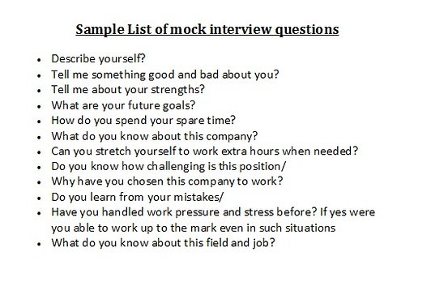

EXERCISE- Prepare mock-interview question for two celebrities.

Lab Module – 8

PROFESSIONAL RESUME WRITING

SUMMARY OF KEY CONCEPTS
A resume is a formal document created and used by a person to show their career background and skills. Resumes are used for a variety of reasons, but they are most often used to secure a new job by supplying information such as relevant job experience and education. Resume originated from the French term resume, which means summary. The term is also similar to the Latin term curriculum vitae, which is a written overview of someone’s life work.

The purpose of a resume is so that a job candidate can introduce themselves to their employer, present their qualifications, and hopefully obtain an interview. A resume should include a candidate’s experience, education, and skills in an easy-to-read format.

A resume is typically limited to one or two pages of size A4 or letter size. It highlights only the experience and skills the candidate considers the most relevant to the desired position they are applying to. A good resume contains keywords or skills the employer is looking for, heavily uses active verbs, and displays the content in an attractive manner. The complexity or simplicity of a resume varies from person-to-person occupation to occupation. For example, a doctor or professor may have a longer resume than a general business resume because of the specialized field. Other industries may require special cases. An artist might include an extensive list of solo or group exhibitions they’ve shown.

RESUME WRITING TIPS
Here are some tips for writing a successful resume:

- Use a legible font and set the size to 11 or 12 pt.
- Present contact info in a separate resume header.
- Keep the resume short and direct. A common rule of thumb is to keep the resume under one page in length.
- Use bullet points as recruiters are more than likely going to be skimming the resume first.
- List the most recent job experience first.

TYPES OF RESUMES
The four standard types of resumes include:

Chronological: The most commonly-used format. Work history is listed in chronological order, starting with the most recent job. This type of resume is useful for those with a solid work history and no lapses in careers.
Functional: A functional resume focuses on skills and experience first. It downplays the dates worked and employment history. This type of resume is useful if there are lapses in employment or no clear career path is evident.
Combination: A combination resume details both skills and experience along with a chronological work history. This format is useful for tailoring the resume to prospective job openings.
Targeted: A target resume is customized in detail to the prospective employer. Objectives, qualifications, and education mirrors the job requirements. This format is the most time consuming as it must be changed for every job applied for. It is, however, the most effective when applying online as each company has specific keywords they are looking for.

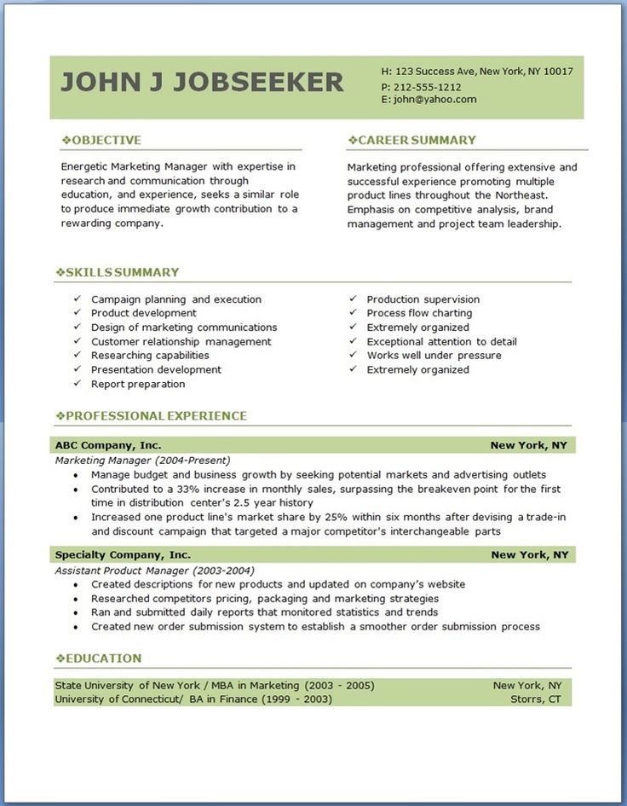

SAMPLE: Sample for resume writing
EXERCISE: Student are assigning to create their resume.

https://www.jobscan.co/resume-writing-guide

Lab Module – 9

PORTFOLIO DEVELOPMENT

SUMMARY OF KEY CONCEPTS
Showcase portfolios are collections of a person’s best work, chosen by the individual. These portfolios are often used for job interviews or teacher-of-the-year competitions. The purpose of the portfolio is for a student to showcase his or her best work in one or more areas. For example, the student could develop a showcase portfolio to prepare for a teaching award. The portfolio would contain evidence chosen by the developer. This evidence would be what the developer believes to be his or her best work & achievements in their academic period. Some developers might place several best lessons in their showcase portfolios.

Portfolio is a reflection for any showcase portfolio would focus on why evidence was chosen and why it is deemed best work. The main idea of this portfolio is that the developer chooses what to showcase and how to organize it. Unlike the other two types, this portfolio is completely individualized and is based on the perceptions of the individuals about him- self or herself.

WHAT ARE THE DIFFERENCES IN THE THREE PORTFOLIOS?
All three types of portfolios are purposeful collections of evidence with thoughtful reflections. The difference between the portfolios revolves around three components:
(1) The purpose of the portfolio,
(2) What type of evidence is collected, and
(3) How the evidence is collected.
The “what” and “how” of evidence collection is a direct result of the portfolio’s purpose. For example, in a process portfolio with a purpose of showing the progress of key skills, the “what” of evidence would be a collection of documents that show the major skills which helps individual to add something new as quality in students. showcase their personality, while the “how” would be the developer’s choice. For the student portfolio with the purpose of demonstrating the work done by student in their academic year this also include the achievements, research work, and other curriculum activities perform by the students.

LAB EXERCISE/ASSIGNMENT
Make your portfolio by adding all your achievements, awards, audio, video and good work into it.

SAMPLE:

Bibliography

- https://www.verywellmind.com/what-is-the-thematic-apperception-test-tat-2795588
- https://gdpi.hitbullseye.com/Group-Discussion-Etiquette.php
- https://www.mindtools.com/pages/article/team-building-problem-solving.htm
- https://www.mindtools.com/CommSkll/RolePlaying.htm
- https://gdpi.hitbullseye.com/Group-Discussion-Etiquette.php
- https://www.psychestudy.com/general/personality/detailed-procedure-thematic-procedure-test
- https://sbccimplementationkits.org/provider-behavior-change/lessons/step-1-conduct-situation-analysis/
- https://www.indeed.com/career-advice/career-development/how-to-write-an-official-letter
- https://in.indeed.com/career-advice/interviewing/mock-interview
• https://mamoonaghaffar862.medium.com/what-is-the-purpose-of-portfolio-development-98d07c0564c9

➢ BOOKS (CITATION)
Soft Skills: Tools for success, Author: Gupta Rajat, Publisher YKings Books: Mc Graw-Hill, Edition 1 of year 2012.
Behavioural Science: Achieving Behavioural Excellence for Success, Author: Singh Abha, Publisher Wiley India Private Limited, Edition

